

Final Report

Course: MAE 159 - Aircraft Performance

Advisor: Prof. Robert Liebeck, Prof. Jacqueline Huynh  
T.A. Seraphin Yeung

Author: Triet Ho

Winter 2025 specifications:

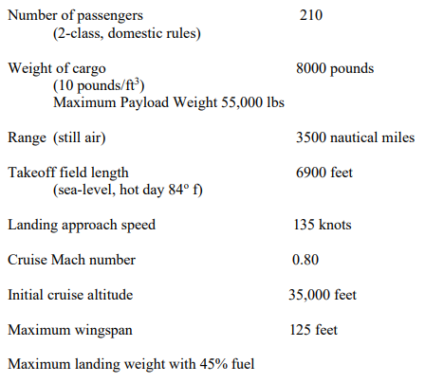

**Engine Configuration:** 2 JT9D-class engines, wing-mounted

**Seating Layout:** 6 abreast

**Wing Design:** Taper ratio = 0.35

Date: March 1st, 2025

# 1. Approach

In this study, commercial transport conventional aircraft design and advanced technology aircraft design are compared for economic performance. Both designs have to satisfy all the specifications requirements and safety requirements while keeping Direct Operating Cost (DOC) as low as possible.

## 1.1 Design Specifications

|  |  |
| --- | --- |
| **Specification** | **Value** |
| Number of Passengers | 210 (2-class, domestic rules) |
| Cargo Weight | 8,000 lbs (10 lbs/ft³) |
| Maximum Payload Weight | 55,000 lbs |
| Range (still air) | 3,500 nautical miles |
| Takeoff Field Length | 6,900 feet (sea-level, hot day 84°F) |
| Landing Approach Speed | 135 knots |
| Cruise Mach Number | 0.8 |
| Initial Cruise Altitude | 35,000 feet |
| Maximum Wingspan | 125 feet |
| Maximum Percent Fuel Weight at Landing | 45% |

Table 1: Aircraft Design Specifications

Table 1 shows the specifications that the two aircrafts are required to meet. These design parameters define the aircraft’s operational capabilities, including passenger and cargo capacity, cruise range, takeoff field length, landing performance, and other aerodynamic constraints. Besides these explicit specifications, the two aircrafts also have to meet all safety requirements such as minimum 1.3 stall velocity operation and passing safety gradients in all flight segments. Optimization is performed by parallelly clearing all requirements and iterating aspect ratio (AR) and swept angle (Λ) for minimum DOC. Other properties of the aircraft are then extracted and calculated from the MATLAB code for further sizing procedure and final design in Solidworks. This process is done twice for the conventional aircraft design and the advanced technology design.

## 1.2 Wing Sizing Results

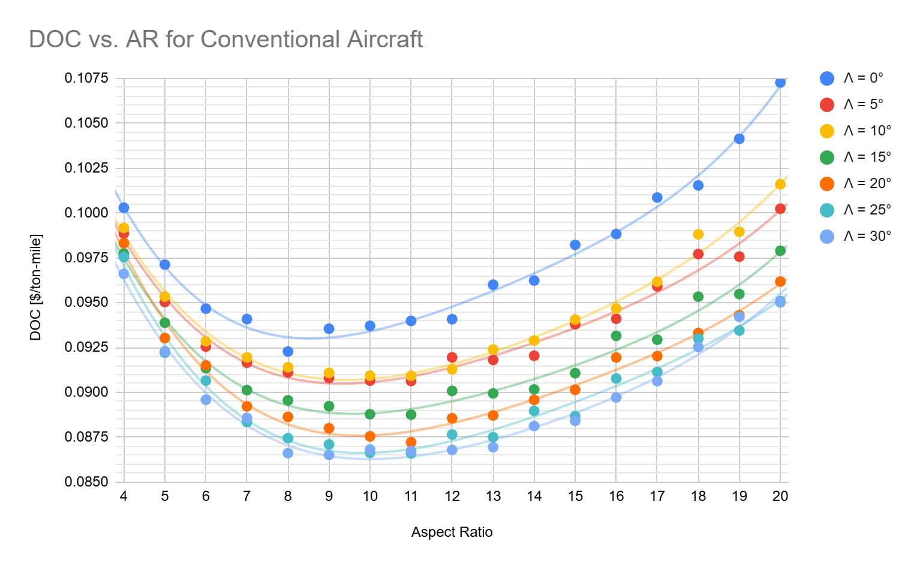

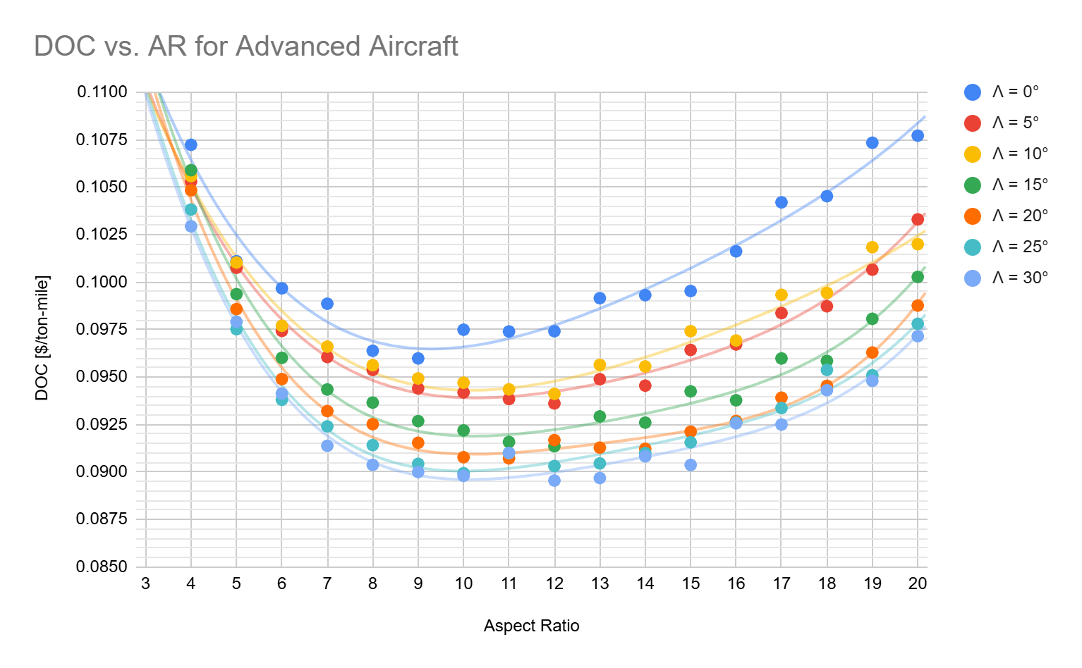

Figure 1: DOC vs. AR for All Aluminum (top) and for All Composite (bottom)

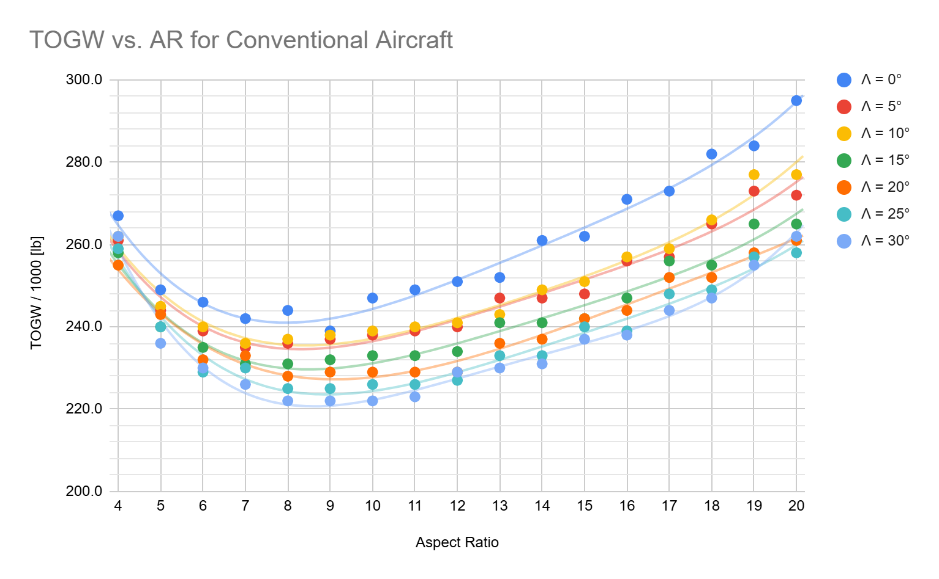

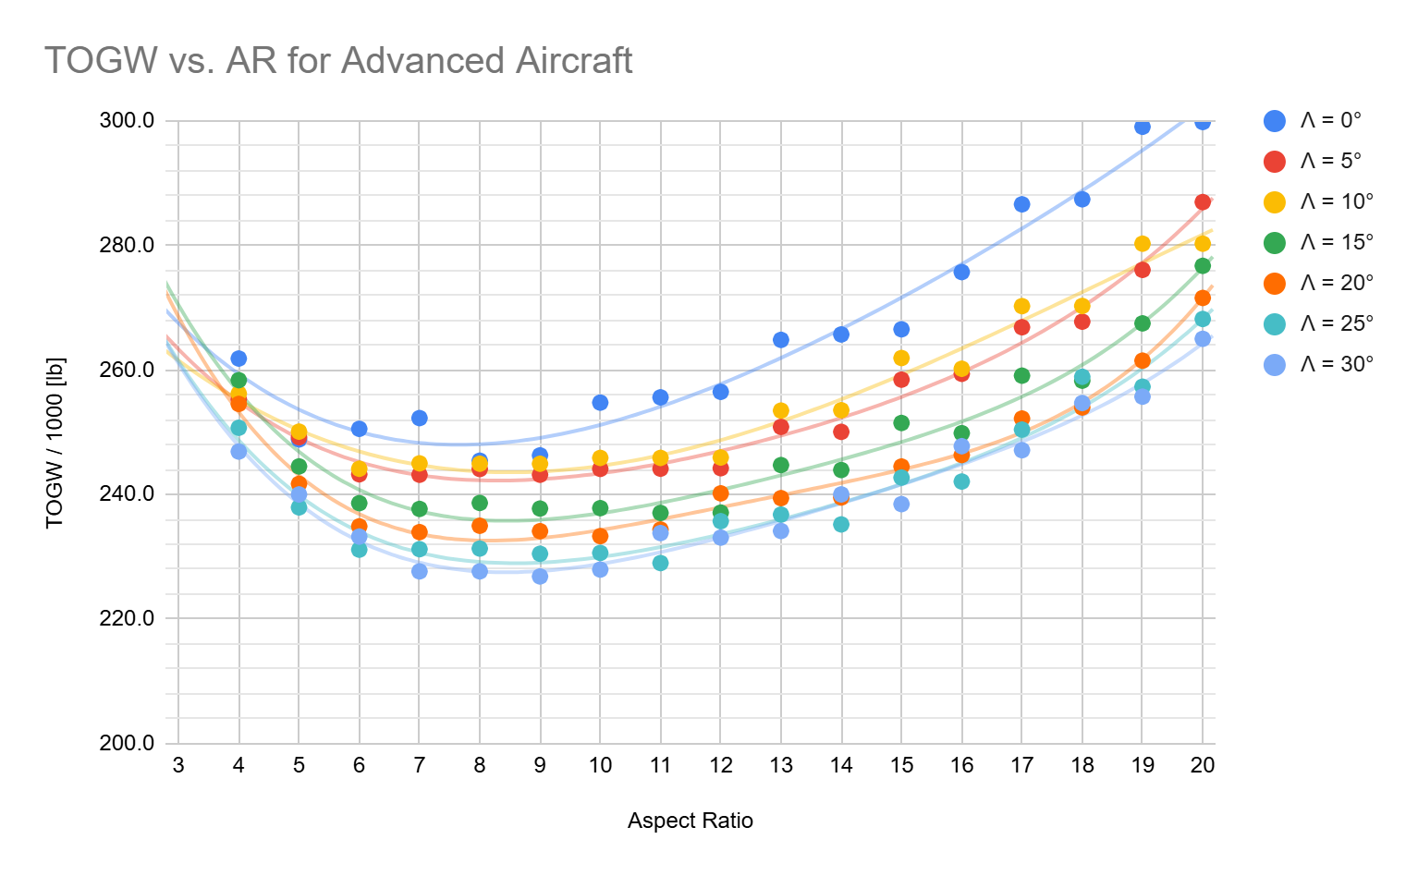

Figure 2: TOGW vs. AR for All Aluminum (top) and for All Composite (bottom)

It's worth noting that both DOC vs. AR graphs and TOGW vs. AR graphs converge at the same AR and Λ. Therefore, minimizing DOC is the same as minimizing Takeoff Gross Weight (TOGW). This makes sense because TOGW and DOC have a linear relationship. As TOGW increases, DOC increases and as TOGW decreases, DOC also decreases.

Aspect ratio trend is in U shape. At extreme low AR, 4, and extreme high AR, 20, the DOC is significantly higher than mid range AR, 7-11. The AR that gives the lowest DOC is around 9, which is expected for most current commercial aircrafts [1]. However, due to the Maximum Wingspan requirement in Table 1, AR is chosen to be 8. At AR value at 9 and above, the wingspan is greater than 125 [ft], thus disqualifying them from design consideration.

Swept angle trend is opposite to DOC. As Λ increases, DOC decreases. Therefore, Λ should be as high as possible to minimize DOC. However, when Λ is too high, the designs cannot pass all specifications and safety requirements. This leads to Λ stops at 30° for both designs because higher Λ values aren't able to pass safety gradients.

## 1.3 Primary Analysis: Detailed Composite vs Aluminum

|  |  |  |
| --- | --- | --- |
| **WEIGHT [lb]** | **Conventional** | **Advanced** |
| Wing | 22,077.63 | 22,559.16 |
| Fuselage | 2,542.66 | 2,557.72 |
| Nacelle + Pylon | 4,661.90 | 4,842.47 |
| Tail | 4,342.67 | 4,437.39 |
| Power Plant | 23,463.19 | 25,809.51 |
| Fixed Equipment | 37,630.00 | 37,827.83 |
| Fuel | 64,994.09 | 72,136.82 |

Table 2: Components Weight Comparison Between Conventional and Advanced Designs

Specific fuel consumption (SFC) for conventional aircraft design is 0.68 while SFC for advanced aircraft design is 0.61 because advanced engines provide a 10% decrease in SFC.

In conventional aircraft design, all components are in aluminum while in advanced aircraft design, all components are in composite material. In particular, wing and tail components weight decrease 30%, fuselage weight decreases 15%, fixed equipment weight decreases by 10%, nacelles and pylons decrease by 20%.

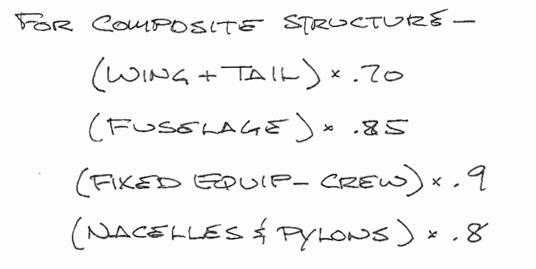

Figure 3: Course Manual Advanced Technology Weight Change

The only exception is the power plant because for advanced technology, the power plant weight is 10% higher to trade off for the 10% decrease of the SFC. Composite material is lighter than aluminum, so theoretically advanced aircraft design should have lower weight compared to conventional aircraft design. However, because of the increase in power plant weight and decreases in SFC, the design optimization loop changed the configuration into a different optimal TOGW thus changing the weight of all components.

## 1.4 Aircraft Comparison Specs

|  |  |  |
| --- | --- | --- |
|  | Conventional | Advanced |
| **WING** | | |
| Wingspan [ft] | 123.02 | 122.40 |
| MAC [ft] | 16.57 | 16.48 |
| Planform Area [ft^2] | 1,891.67 | 1,872.76 |
| Airfoil Type | Supercritical | Supercritical |
| Aspect Ratio (AR) | 8 | 8 |
| Swept Angle (°) | 30 | 30 |
|  |  |  |
| **FUSELAGE** | | |
| Length [ft] | 165.78 | 165.78 |
| Diameter [ft] | 14 | 14 |
| Seats Abreast | 6 | 6 |
|  |  |  |
| **MATERIAL** | | |
| Wing | Aluminum | Composite |
| Fuselage | Aluminum | Composite |
| Nacelle + Pylon | Aluminum | Composite |
| Tail | Aluminum | Composite |
| Fixed Equipment | Aluminum | Composite |
|  |  |  |
| **WEIGHT [lb]** | **Conventional** | **Advanced** |
| Wing | 22,077.63 | 22,559.16 |
| Fuselage | 2,542.66 | 2,557.72 |
| Nacelle + Pylon | 4,661.90 | 4,842.47 |
| Tail | 4,342.67 | 4,437.39 |
| Power Plant | 23,463.19 | 25,809.51 |
| Fixed Equipment | 37,630.00 | 37,827.83 |
| Fuel | 64,994.09 | 72,136.82 |
| **ENGINES** | | |
| Flat Plate Drag Area [ft^2] | 30.77 | 30.60 |
| Engine Type | JT9D | JT9D |
| Number of Engines | 2 | 2 |
| Max Thrust per Engine [lb] | 43,857.47 | 44,154.67 |
| Takeoff Gross Weight [lb] | 222,000.00 | 227,652.24 |
| All-out Range NM | 4,045.84 | 4,045.84 |
| DOC [$/ton-mile] | 0.0865 | 0.0900 |
|  |  |  |
| SFC | 0.68 | 0.61 |
| Powerplant Weight [lb] | 24,501.38 | 26,951.52 |

Table 3: Specification Comparison Between Conventional and Advanced Designs

The comparison between the conventional (full aluminum) and advanced (full composite) aircraft designs reveals a nuanced balance of performance, efficiency, and economic considerations. Both configurations use a supercritical airfoil with similar wing dimensions, maintaining an aspect ratio (AR) of 8 and a swept angle of 30 degrees. This consistency ensures aerodynamic efficiency is primarily determined by structural materials rather than geometric differences. The full composite wing, though slightly heavier (22,559.16 lb) than the aluminum wing (22,077.63 lb), may offer better durability and reduced life-cycle maintenance. The small increase in weight might reflect enhanced structural integrity offered by composites. Both configurations employ JT9D engines, but the advanced design achieves slightly higher thrust per engine (44,154.67 lb vs. 43,857.47 lb). This reflects the ability of composite materials to endure greater stress, possibly enhancing propulsion efficiency. The composite design, with its sophisticated material technology, results in higher fuel capacity (72,136.82 lb vs. 64,994.09 lb) to potentially expand operational range under heavier payloads. However, this benefit comes with an increased Direct Operating Cost (DOC) of $0.0900/ton-mile compared to the aluminum design’s $0.0865/ton-mile. This suggests that while composites offer performance improvements, they might slightly elevate operational expenses without significant cost-offsetting measures.

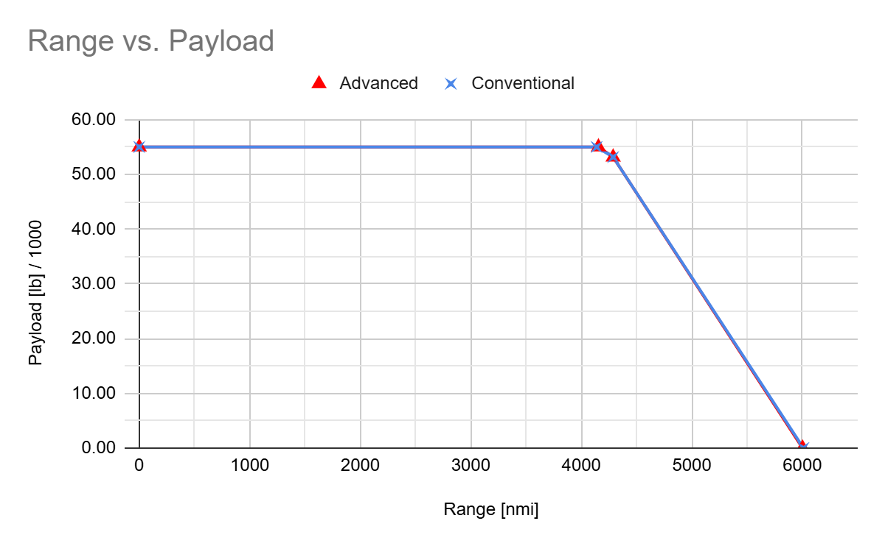

1

2

3

4

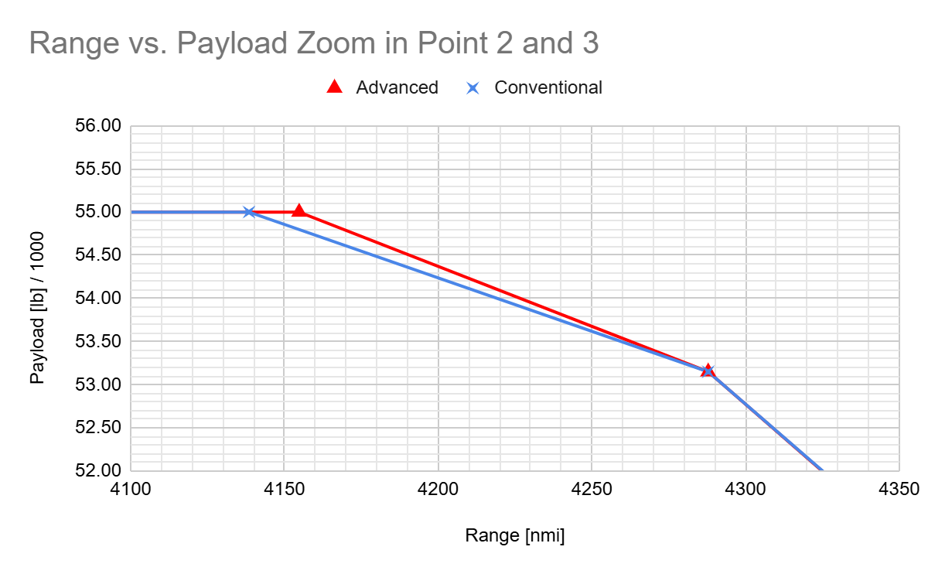

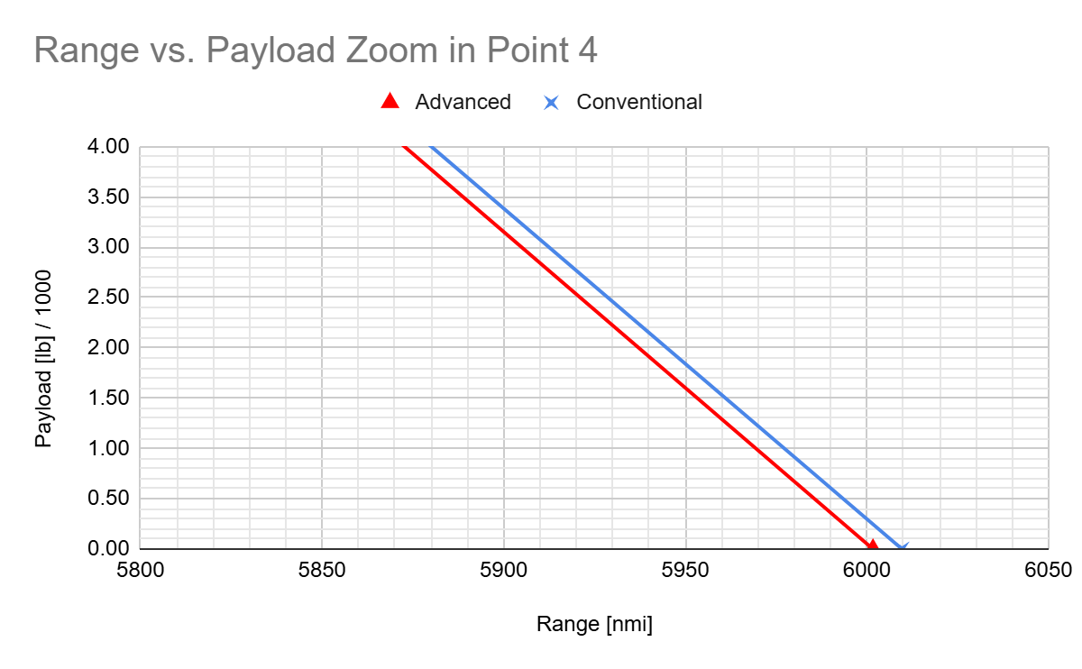

Figure 4: Payload Range Chart

# 2. Results and Conclusions

After a thorough analysis and comparison of the conventional aluminum and advanced composite configurations, the decision is made in favor of the full aluminum configuration. This choice is based on a combination of efficiency, cost-effectiveness, and familiarity that aligns well with operational and strategic goals.

Aluminum has a long history in the aerospace industry, providing proven reliability and durability. The material's known performance characteristics reduce the risk associated with adopting new technologies and support consistent operational outcomes. The production and material costs for aluminum are markedly lower than those for advanced composites. This results in substantial savings upfront, allowing airlines to allocate resources to other critical areas such as training, maintenance, and expansion. Aluminum's extensive use means simplified maintenance procedures and a wide availability of repair expertise and parts. This leads to reduced maintenance downtimes and costs throughout the aircraft’s lifecycle, enhancing overall operational efficiency.

DOC for conventional aircraft is lower compared to advanced aircraft. Therefore, by continuing with aluminum, airlines capitalize on a well-understood material while remaining competitive in markets dominated by cost-sensitive decisions. This choice also supports a conservative risk profile, appealing to stakeholders prioritizing stability and predictability.

# 3. Description of the Configuration

## 3.1 Wing and Tails

Wing AR, Λ, and reference area (Sref) is taken from MATLAB code and analysis above. Then using equations in Schaufele textbook, the rest of the information of the wing can be calculated.

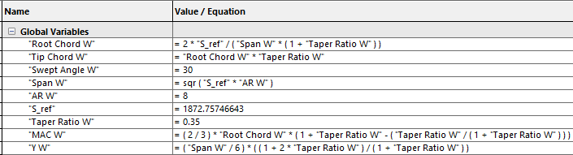

Table 4: Equations for Wing in Solidworks

Here the calculation was computed inside Solidworks Equations so that they can be directly implemented in the 3D design as variables. In later design and sizing processes, when these parameters need to be changed, they can be changed easily and updated systematically in Solidworks to smooth out the design process.

For tail sizing, Schaufele is heavily utilized. Tail Volume was determined from the graphs in Fig. 6-9 and 6-15 of Schaufele. This value is then double checked in Tables of Fig. 6-10 and 6-16. Schaufele Fig. 6-17 and 6-18 are used to determine the AR and Taper Ratio (λ) for the tails. These values are a good first estimation of tails. For actually accurate values, however, course MAE 175 offers a more detailed analysis for flight dynamics stability and sizing procedure for tails to keep the aircraft stable during flight.

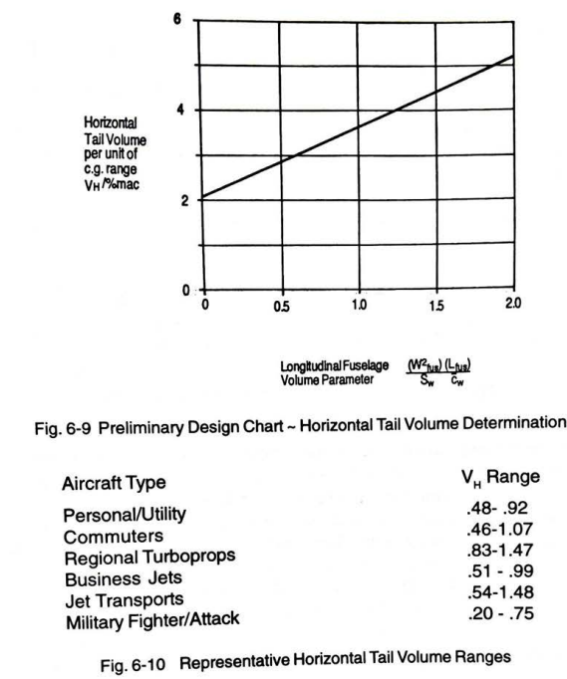

Figure 5: Fig. 6-9 and 6-10 from Schaufele for Horizontal Tail Volume

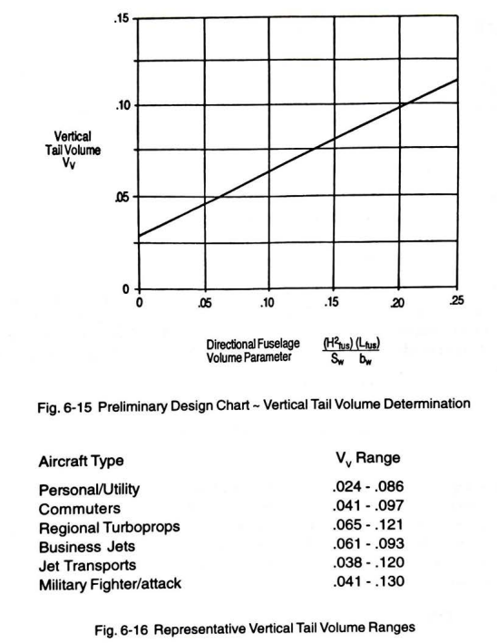

Figure 6: Fig. 6-15 and 6-16 from Schaufele for Vertical Tail Volume

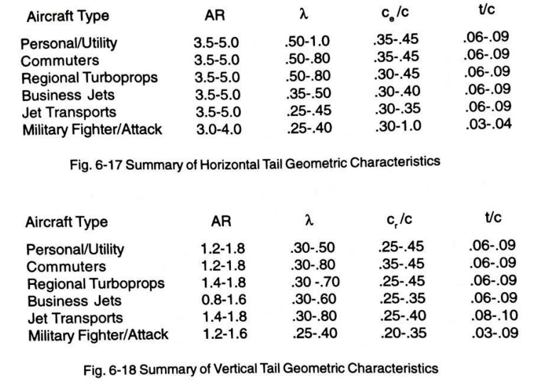

Figure 6: Fig. 6-16 and 6-17 from Schaufele for Tail AR and Taper Ratio λ

Instead of approximate fuel tanks as rectangles, the fuel tanks for the aircrafts are sized inside Solidworks, the shape is a smaller scaled version airfoil shape of the wing so that it can fully take advantage of the available space and affect CG location as small as possible. In fact, in aircraft stability, fuel tank is a component that changes weight the most, therefore, to ensure stability, fuel tank CG needs to be as close to quarter chord MAC as possible.

Insert figure for fuel tank in Solidworks

Front and rear wing spar locations are sized as recommended in Schaufele to be 15% to 75% of the chord. This is extruded all the way from root chord to tip chord. After that, the fuse tank is iteratively cut back from tip airfoil side until the desired fuel tank volume is reached.

✅

## 3.2 Fuselage and Exterior Configuration

- Briefly discuss justification for selecting the following secondary parameters: o Fuselage Shape, Nacelle Sizing, Landing Gear, Cargo Containers ect…

Fuselage nose and tail was traced from the B737 aircraft drawing and scaled up to the required dimension of the diameter and length for the aircrafts. For fuselage, the first cut is taken from the MATLAB code for a maximum fuselage length. After doing the interior layout in Section 3.4, a second cut is made for the minimum fuselage length. The fuselage length is then iterated in Center of Gravity (CG) sizing, increase from minimum fuselage length to maximum fuselage length to make sure stability is satisfied while keep the length as short as possible to avoid unnecessary weight and material cost.

## 3.3 Center of Gravity Design

This follows Center of Gravity (CG) sizing procedure to make sure the aircraft CG location is always around MAC quarter chord for a tolerance of 10%. There are four extreme conditions the aircrafts can be in.

- Present all 4 C.G. design scenarios - Summarize 4 locations as well as operational weight in a table

## 3.4 Interior Configuration

Course manual specifies how interior layout needs to be done. Also, PAX is the constraining parameter in this step.

- Describe selection process and reasoning for 2 class interior configuration: seats, pitch, aisle width, # lavs, # galleys, # carts, doors type , # exits, ect

Because the range specification is at 3,500 nautical miles, the aircrafts are considered as Medium Range. From the Course Manual page 92, Table 2, all the necessary variables can be obtained to design the interior layout of the aircrafts.

First part of interior configuration of the aircrafts is the circular cross section at middle of the fuselage.

Insert cross section

The cargo is in the bottom while passengers are on top.

After this is done, now the second part of interior configuration is the seating layout where the aircraft is cut horizontally in side view at the floor in the first part.

## 3.5 Selected Aircraft Configuration

Table

# 4. Configuration Drawings

Separate page

# 5. Conclusion

½ page on final thoughts

# 6. Work Cited

[1] [Performance predictor - Aerospace America](https://aerospaceamerica.aiaa.org/departments/performance-predictor/#:~:text=Currently%2C%20most%20commercial%20aircraft%20wings,times%20larger%20than%20its%20area).

[2] [MAE 159 Appendix Hand Cal.pdf](https://drive.google.com/file/d/1y7SXDeWb7Ia6l_xGns1l46QMLrqvvWz0/view?usp=sharing)

[3] [AR_vs_DOC.m](https://drive.google.com/file/d/14fLlYQwbdUpJxwctLbKpAP8mLII-IYFs/view?usp=sharing)

[4] [Weight_takeoff_vs_DOC.m](https://drive.google.com/file/d/1xQAnfXlMSwrLJleUO0mXfP962f77k-Wp/view?usp=sharing)

[5] [AR_vs_Weight_takeoff.m](https://drive.google.com/file/d/1UxCpauHm-jmFf2wLzmtrOVDGLIL3zkz5/view?usp=sharing)

[6] [Course_Manual.pdf](https://drive.google.com/file/d/1R_srrhwgWmxPWReO1l1vmkKgbCeT3X68/view?usp=sharing)

[7] [Psuedo_Code_2.m](https://drive.google.com/file/d/1eAU0DPqmQi-WlmplU8S2BqX1Ai4Tx_JJ/view?usp=sharing)

[8] [Sample_Calculation.m](https://drive.google.com/file/d/1wfAIeoJCgaiX3wWKvcd1RZtALeLmCoSw/view?usp=sharing)

[9] [Schaufele.pdf](https://drive.google.com/file/d/1BmXY2pKnwyooJREKoaiNwLT0T9g4C4WU/view?usp=sharing)